

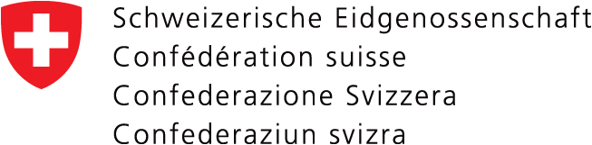

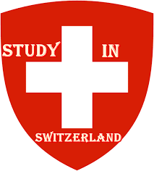

|  |  |
| --- | --- |
| 1. **Scholarship offers:**     **Swiss Government Excellence Scholarships cover:**   * Stipend: Postdoctoral research: CHF 3500 (R74,064,90) per month; * Stipend: PhD and Research scholarship: CHF 1920 (R40,629,90) per month; * Mandatory Swiss health insurance; * One-time lump sum of CHF 300 (R6,348,42) with the first grant payment to help for payment of the housing deposit; * A one-way flight to Switzerland for the scholars will be covered by the DALLRD. * Flight allowance (lump sum) for a ticket back to their country of origin (provided at the end of the scholarship).  1. **Who is eligible to apply?**  * South African Citizen * Applicants who have been in Switzerland since more than one year at the beginning of the scholarship in September are not eligible. Reference document if applicable: residence permit to be added to the application documents. * Applicants who have already benefited from a Swiss Government Excellence Scholarship are not eligible to apply for a second scholarship.  1. **Application process**     Applications must be submitted to the Embassy of Switzerland in South Africa. The applicants are strongly advised to use a courier company to submit their application. To prepare a successful application, please carefully read the application guidelines (Attached).   1. **Deadline**   The application deadline is. **15 December 2023**. Copies of your application forms must also be submitted to Ms Jacky Smit ([JackyS@Dalrrd.gov.za](mailto:JackyS@Dalrrd.gov.za)) before or on the given deadline. | 1. **Fields of study:**      * Applications are open to all fields of study in science, engineering, and technology in the agricultural sector and niche courses not available in South Africa will get priority. Please see attached the Department of Agriculture, Land Reform and Rural Development’s research priority list.   **For South African citizens, three different types of fully funded scholarships are offered starting in September 2024 in all academic fields:**  **PhD scholarships**   * The scholarship is valid for 12 months and renewable for a maximum of three years. * Applicants should have a master’s degree or equivalent university degree recognised by a Swiss University obtained before 31 July 2024. * The applicant must not be older than 35 years at the time of application (Born after 31 December 1988).   **Postdoctoral scholarships**   * The scholarship is valid for 12 months and non-renewable; * Grant applications for stay lasting less than nine months will not be treated as a priority; * Grant applications for stay lasting less than six months will be rejected. * The applicants should have a PhD degree; * PhD degree must be obtained after 31 December 2019 and before 31 July 2024 (PhD degree certificate).   **Research** **Scholarships**  **The scholarship is intended for highly qualified postdoctoral researchers from all academic fields:**   * The scholarship is valid for 12 months maximum and non-renewable; * Grant applications for stay lasting less than nine months will not be treated as a priority; * Grant applications for stay lasting less than six months will be rejected; * The applicant should have a master’s degree or equivalent obtained before 31 July 2024; * Mandatory letter from an academic host professor (including her/his short CV); |

|  |  |
| --- | --- |
| **Enquiries:**  Ms Jacky Smit  Tel.: 012 319 7019  Email: [JackyS@Dalrrd.gov.za](mailto:JackyS@Dalrrd.gov.za) | Ms Cadorah Rachidi  Tel.: 012 319 7259  Email: [CadoraM@Dalrrd.gov.za](mailto:CadoraM@Dalrrd.gov.za) |



The Swiss Government is offering foreign researchers’ postgraduate scholarships at Swiss higher education institutions (universities, federal institutes of technology and universities of applied sciences, Arts and music schools) through the Swiss Federal Commission for Scholarships for Foreign Students (FCS also known as ESKAS, CFBE). The Swiss Government Excellence Scholarships are intended for highly motivated, competitive young researchers who have graduated from university (postgraduates). These scholarships will enable applicants to undertake research work in the fields in which the Swiss universities are particularly active.

Swiss Government Excellence

Scholarships 2024 to 2025